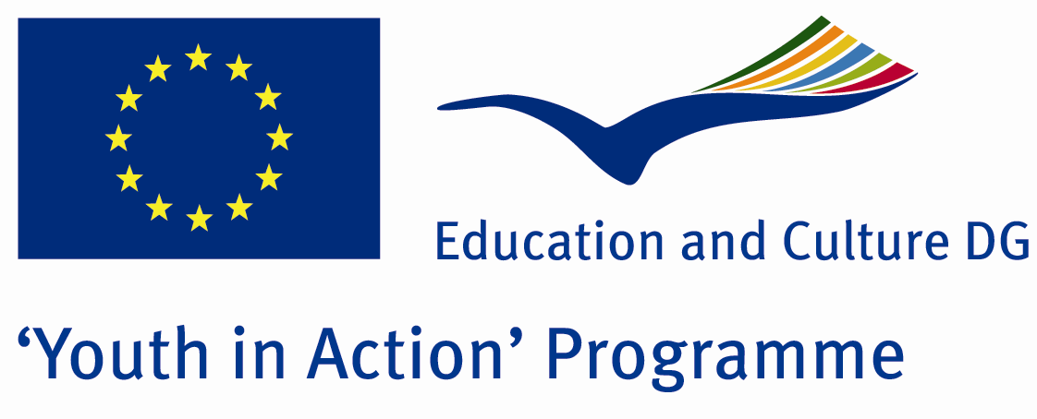

Ugly Buildings

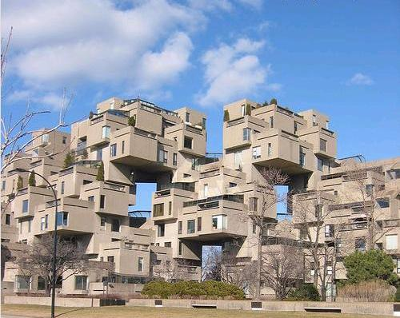

ACTION 4.3 – Training And Networking

24-30th August 2011

Aydin/TURKEY

Please contact directly to;

adventurerpeacepigeons@gmail.com

Project Summary;
Tipsy urbanization is a common problem of europe union and all the world countries.when we say tipsy urbanization, at first we form a Picture of building stacks which are unquality, rotten and ugly.This opinion is true..but it can’t be explained with just only this.In fact, tipsy urbanization means residental plan which destroys natural balance too, even if the buildings are strong…Here in this project, we try to teach our participants some information about this subject.some specialits will particpate to our Project and we try to learn the answers of some questions from them…what is the damage of tips urbanization? In the future , what will be the conclusion of this? Can we leave a good world for our grandsons?Because of destroying the natural balance, leads to many disasters like floods,earthquake and erosion…

Project Title; Ugly Buildings

Date and Venue; 24-30th August 2011 Aydin/TURKEY

Target Group; Non profit/non governmental organization, Public body, Body active at European level in the field of youth (ENGO), Informal group of young people, e.t.c…

Participants; 5 people from each country (18 - 25). Totally 8 countries.

Conditions; Accommodation, board and programme costs will be financed through European Commission Youth in Action Programme (Action 4.3). Travel costs will be reimbursed in 70% (APEX Tarrifs). Organizations from all 27 EU member countries plus Liechtenstein , Norway and Iceland are eligible to take part.

Working language: English

Organizer; Discovery And Adventure Group

How to apply: If you are interested, please send your Part III forms to
0090 216 483 21 67 by FAX please. (Fulfilled Part III which you can find in the attachment, of course signed and stamped) ..

Note: jpeg is not allowed..please send by fax…

Next step 2;
Original send via regular post to this address please:
Ertan DERİN
Öner İnşaat
Abdulhalik Renda Cd.
Parlar Sk. No:4 Pendik/İSTANBUL

If you have any questions you may contact with: adventurerpeacepigeons@gmail.com

Deadline for application; until 20th January 2011.
For Further information:
Contact Person
Ertan DERİN
Öner İnşaat
Abdulhalik Renda Cd.
Parlar Sk. No:4 Pendik/İSTANBUL

e-mail : adventurerpeacepigeons@gmail.com
Mobile : 0090 542 393 93 90
Fax : 0090 216 483 21 67

